Abdullah Salem Mohammed Al Hababi 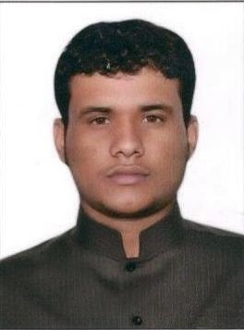
Khalidiya District
Riydh, Saudi Arabia
Riyadh Mobile # (+966) 538782436
alhababi500@gmail.com

Objective
To work, learn and grow in highly esteemed organization that will sharpen my working abilities and help me in contribution towards corporate advancements.

WORK EXPERIENCE

Parts Warehouses operator

Universal Motors Agencies
Riyadh, K.S.A
January 4, 2013 to Present

Duties and Responsibilities:
- Responsible for safety, integrity and security of all items inside warehouse.
- Health & Safety compliance in accordance with company policy.
- Provide leadership by establishing clear expectations and demonstrating high standards of work practices and safety conscious behavior.
- Communicate & Implement changes as directed by my superior.
- Coordinate with management / end user related materials issues
- Receiving of materials and conduct initial inspection of actual items vs. items on the documents received.
- Unloading of received items wherein in charge of where the items will be unloaded, proper unloading process and safety in materials handling.
- Update Database Inventory of materials based on daily received and shipped items.
- Picking of ordered items
- Documentations for shipping of items
- Conduct Monthly Actual Inventory of Materials with Accounting Department for Monthly audit report.
- Conduct Annual Actual Inventory of Items with Accounting Department for Audit Report.
- Ensure cleanliness of working area (5S).
- Document preparation on all outgoing items.
- Filing of documents
- Perform other duties that may assign from time to time
EDUCATIONAL BACKGROUND

Primary & Secondary Rabat Basic School
2000 – 2008 Hadramout, Yemen​
Achievements:

Employee of the Month-December 2015
Universal Motors Agencies KSA

5 Years Service Awardees - 2018
Universal Motors Agencies KSA
PERSONAL PROFILE
Birth Date: June 06, 1990​
Birth Place: Hadramout, Yemen​
Sex: Male​
Civil Status: Married​
Nationality: Yemini​
Religion: Muslim​
Languages Spoken: Arabic and
English low

