Curriculum Vitae

Osama Mohamed Ahmed Mohamed El Khamisy
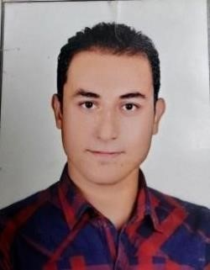

Personal Information
- Date of birth: 06/07/1990
- Nationality: Egyptian
- Gender: Male
- Cell Phone: 00201094906828 / 00201126862040
- Address: 9 Wabour Esmat St., Ain Shams, Cairo, Egypt.
- Marital Status: Married
- Military Status: Completed
- E-mail: oss13117@gmail.com

Objective
- Seeking a challenging career to enhance my characteristics and qualifications in order to be able to have a reputable position in a unique where my interpersonal, communication, and leadership skills applied and further developed.

Educational Background
- Bachelor of Arts, Ain Shams University

Current Position
- From2012 to2022 in bmw.
5 years technician
4years loading
1 year Service Advisor.
- From 2022,till now Sylndr egypt
Inspection technician

Skills
- Language:

  - English: Good
  - Arabic: Mother tongue.

- Computer Skills:

  - Perfect in Microsoft office programs.
  - Ability to use different visions of windows.
  - Using internet applications and researches.

- Personal Skills:

  - Communication skills.
  - Negotiation skills.
  - Presentation skills.
  - Working under stress.
  - Fast learner.
  - Team working skills.
  - Commitment.
  - Creative and attentive to details.
  - Responsible, reliable and ambitious

