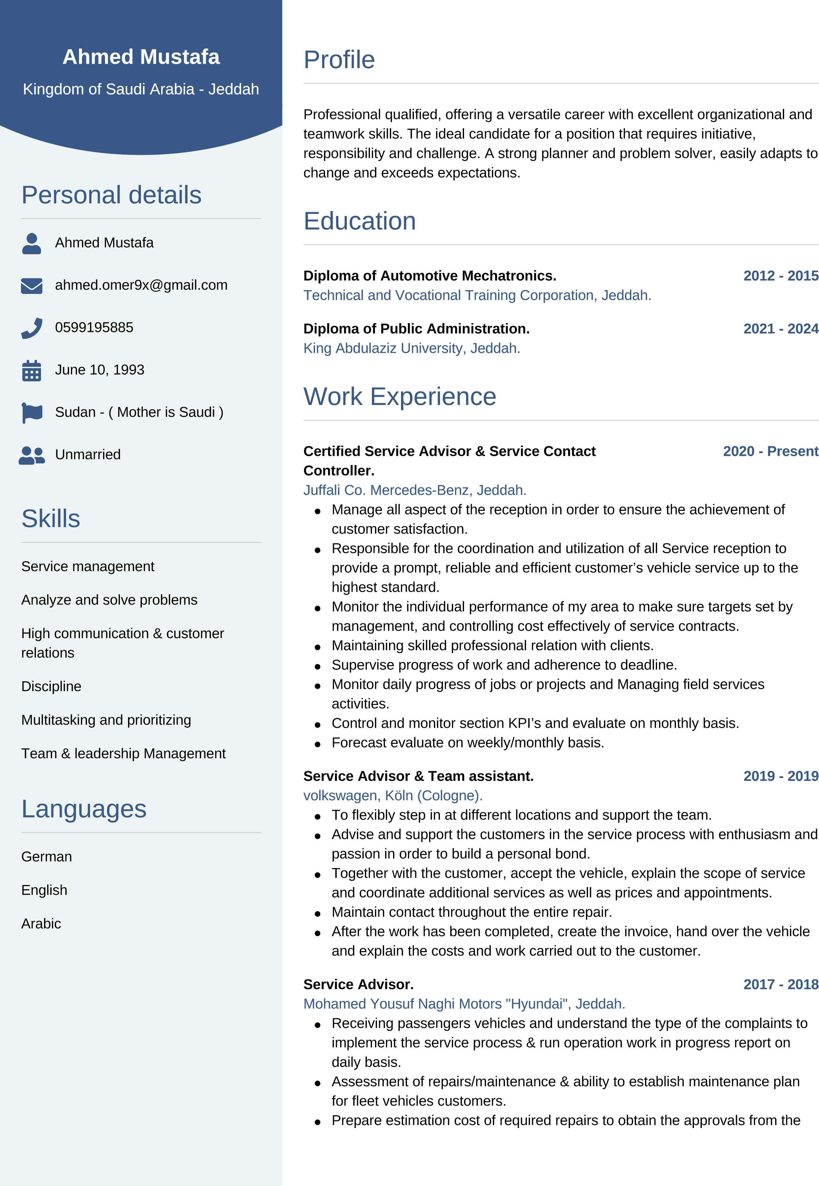
concern
.
Proactive
approach
when
dealing
with
customer
complaints
with
ability
to
resolve
.
Automotive
Mechatronics
.

2012

-
2017
Mohamed
Yousuf
Naghi
Motors
"
Hyundai
"
,
Jeddah
.
Carrying
out
inspecting
,
maintaining
&
repairs
vehicles
.
Certificates
Training
Course
Certificate
for
Santa
Fe
Technology
AMTA
from
Hyundai
Co
.
2018
Course
-

German
Automotive
Technology
.
2019
German
Language
Certificate
"
Internationally
Accredited
"
Telc
.
2020
Juffali
Co
.
(
Jipco
)

Appreciation
Certificate
2021
Certificate
of
Excellence
Customer
Service
.
Mercedes
-
Benz
(

Daimler
AG
)
.
2023

