
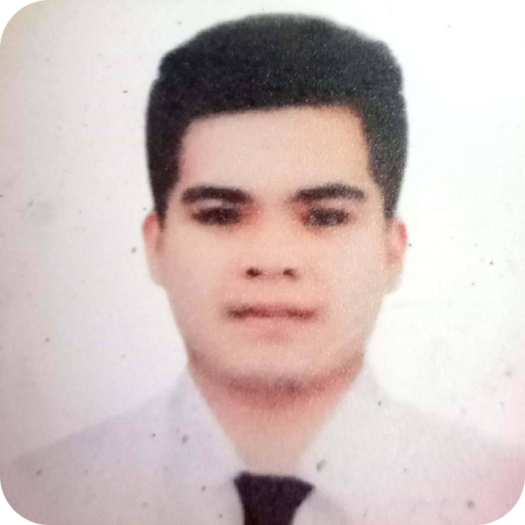
Marvin C. Tutor
Block 24 Lot 21 Apitong St. Barangay 145 Zone 16 Pasay City, Philippines 1300
marvintutor24@gmail.com | 0562545122 | DoB: October 28, 1999
LinkedIn: marvintutor24@gmail.com
"With a profound commitment to critical thinking, exemplary time management, and empathetic
communication, I am dedicated to delivering optimal results and bespoke solutions that effectively
address customer needs. My adeptness at understanding and appreciating diverse perspectives empowers
me to offer efficient and compassionate customer service, ensuring that each client's unique requirements
are met with utmost professionalism and care."
PROFESSIONAL EXPERIENCE
09
/22 - 09/
24
Immediate Service for Car Repair Workshop
Automotive Mechanic
It is a establisment workshop located at Sabt Al alayah Jeddah Balqarn Aseer Region , Saudi Arabia
•
Executed comprehensive underchassis repairs
•
Conducted detailed diagnostics of vehicle electrical systems
•
Performed routine and preventative vehicle maintenance
•
Carried out precise wheel alignment and tire balancing services
12
/21 - 08/
22
American Technologies Inc.
Fleet Maintenance Coordinator
Fleet vehicle monitoring to ensure the safety of the passanger and the driver.
•
Conducted routine and preventative vehicle maintenance
•
Executed underchassis repair and reconditioning
•
Monitored vehicle performance and conditions
•
Performed daily vehicle check-ups
•
Diagnosed and resolved vehicle issues
08
/19 - 01/
20
PGA Cars Inc.
Automotive Technician
•
Performed underchassis repair and reconditioning
•
Conducted vehicle routine and preventive maintenance
•
Carried out vehicle pre-delivery inspections
•
Executed basic vehicle programming
•
Diagnosed electrical issues
•
Performed wheel alignment and balancing
•
Communicated with customers to address their concerns
11
/17 - 12/
18
Chevrolet Greenhills
Automotive Mechanic
•
Performed Underchassis Repair and Recondition
•
Performes Vehicle Maintenance
•
Performed vehicle pre delivery inspection
•
Performed wheel alignment and balancing
•
Communicate with the customer concern
02
/17 - 10/
17
Spi Crm Inc.
Customer Service Representative
•
Helping customer concern about their service that been received
•
Providing information to the customer to keep them in touch with the service that they avail
EDUCATION
05
/18 - 05/
21
Don Bosco Institute of Makati
Automotive Mechatronics
•
Batch 6 of PTRCA scholarship under Porsche Management and DBTI
05
/16 - 05/
18
Pasay City West Sr. High School
Automotive Mechanic
05
/12 - 05/
16
Pasay City West Jr. High School
PERSONAL INFORMATION
•
Birth Place - Pasay City
•
Gender - Male
•
Age - 24
•
Nationality- Filipino
KEY SKILLS
•
Time Management
•
Problem Solving
•
Communication Skill
•
Basic Electrical servicing
•
Underchassis Servicing
•
Maintenance Servicing
•
Wheel alignment and wheel balancing
•
Computer Literate
REFERENCES
Muhammad Awad Jabel - Shop Supervisor, Immediate Service for Car Repair Workshop
0504331689
Arnold Tanguileg - Fleet Maintenance Manager, American Technologies Inc.
09561552575
| nolfarmon@gmail.com
Patricia Gonzales - PTRCA Admin Assistant, Porsche Training and Recruitment Center Asia
ptrc-ph@one-bosco.org

