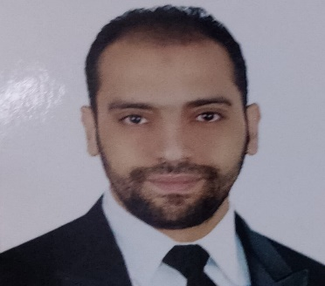 | Mohamed  Farghaly Hamed Hamad
Contact Me  - 0568580799  - mfarghly282@gmail.com  - Iqama Status - Transferable  - Al-Riyadh, KSA  Birth Date  27/Sep/1992  Languages  Arabic "Native"  English "Good"  Skills  - Constructive thinking and problem solving  - Social and emotional intelligence  - Problem solving ability  - Teamwork  - Providing assistance to others  - Communicating with students and parents  - Game-based learning  - Planning and organization  - Knowledge of educational techniques  - Psychological and social knowledge  - Assessment skills  - Behavioral assessment  - Understanding individual needs  - (Excel, Microsoft Word, PowerPoint & Microsoft Access).  - (Ability to deal with Software). | Summary  I had a Master's degree in Mental Health 2023 - Kafr El-Sheikh University, a special diploma in education, specializing in mental health 2018, a professional diploma in education, specializing in special education 2017, and a general diploma in education 2016. I have extensive experience in dealing with many cases of autism spectrum disorder, Down syndrome, delayed speech, hearing impairment, and cochlear implants.  Education  Master of Mental Health 2023 - Kafr El Sheikh University  - Special Diploma in Education, Specialization in Mental Health 2018  - Professional Diploma in Education, Special Education 2017.  - General Diploma in Education 2016  - Bachelor of Fundamentals of Religion and Da'wah 2015- Al-Azhar University  Experience  Resala Center for Rehabilitation of Special Needs, Egypt.  Special Education Teacher - January 2020 – 2023  I worked with children with special needs starting in 2018, at Resala Center for Rehabilitation of Special Needs, then worked with many cases of autism spectrum disorder, Down syndrome, and delayed speech, as well as hearing impairment and cochlear implants, I also worked with children with total or partial blindness.  Training courses  - Speech and communication disorders course for the hearing impaired and hard of hearing, Kafr El-Sheikh University.  - Speech and communication course in the field of autistic children "Autism and its care", Kafr El-Sheikh University.  - Learning difficulties course under the supervision of the Higher Institute of Social Service in Kafr El-Sheikh  - Digital transformation course, Kafr El-Sheikh University.  - Local TOEFL course, Kafr El-Sheikh University.  - license in reading Imam Asim with the arrations of Hafs and Shu'bah from the Shatibiyya path.

