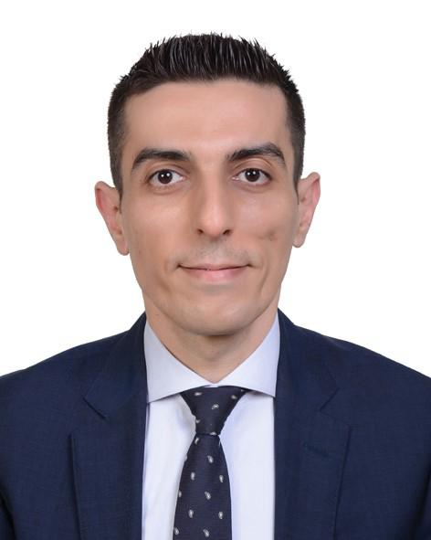
Hani Qwaider
Automotive sales Professional

BIO

PHONE
00966 566446669

EMAIL
qwQwaiderhani8@gmail.comm

ADDRESS:
21463 Jeddah Saudi Arabia

More than 15 years of experience in automotive sales management, whereby I have overseen the development of major brands’ progress at different management levels.

Have a successful past track record in driving sales operations, with focus on customer satisfaction and process optimization. I also oversee and manage the introduction of marketing initiatives, whilst developing clear policies and procedures to ensure staff commitment towards achieving the company’s volume, profitability and quality objectives.





WORK EXPERIENCE

SAMACO – VOLKSWAGEN (Sep 2020 – Dec 2023)
Regional Sales Manager / Riyadh Saudi Arabia (KSA)

Responsible for Volkswagen’s sales operations in Riyadh, including new, used & fleet business. Main scope of work includes focusing on managing sales team as well as exploring new market business opportunities and utilizing (where applicable) any opportunities for expansion in the kingdom.

Duties:
- Develop departments’ short- and long-term strategies to steer brand image in line with overall organizational plans.
- Develop overall departmental (New and used cars sales) financial plans, including marketing, ordering, stock management, staff development and manpower planning while customer satisfactions and financial performance being in focus.
- Manage business plan implementation and ensure all organization objectives are achieved by using and following structured reporting to all stakeholders.
- Oversee the development of corporate’s standard operational manuals and guidelines that best reflect the
corporate’s vision and mission.
- Maximize market exploitation through appropriate sales activities and lead managements in accordance with the strategic objectives and targets.
- Organize promotional and marketing campaigns to create awareness and product publicity.
- Build and maintain strong relationships with individuals &fleet companies to secure long term business relationships and exploring new business opportunities.
- Conduct price and contract negotiations with clients to establish contract details and attain profit margin.

- Conduct market-pricing studies to ensure the right pricing policy is followed and to define market competition.
- Sustain high Level of training within the team, to make sure that every team member has the required knowledge to do his or her job effectively.
- Monitor the regular development of all employees and, to this end, ensure a personnel development plan for each employee.
- Develop incentive scheme to better motivate after sales teams to meet and exceed department targets.
- Create and maintain a management reporting dashboard showing key performance areas of the business covering volume, stock, profit, activity, and quality areas of the business.
- Liaise with after sales department to assure the essential product knowledge is communicated.

SAMACO -Audi
Senior Sales Manager / Riyadh Saudi Arabia (KSA) (Jan 2018 – Mar 2020)
Senior Sales Manager / Jeddah Saudi Arabia (KSA) (Jan 2013 –Dec 2017)

Responsible for the Complete regional sales operations including New, used and fleet sales. With a great focus on Customer satisfaction , employees training and development .

SAMACO -Audi (Nov 2010 – Jan 2013)
Sales Supervisor / Jeddah Saudi Arabia (KSA)

- Showroom Management including maintaining showroom in an adequate condition and CI compliance.
- Supervise salesman performance , appearance and customers handling.
- Manage showroom customer traffic.
- Initiate customer leads lists and follow up contacting process.
- Assist Sales Manager on sales forecast and follow up with salesman to close pending deals.
- Provide sales manager with all required volume and quality reports.
- Following up with PDI and service on cars related to sales department.

SAMACO -Audi (Jan 2008 – Oct 2010)
Certified Sales Consultant/ Saudi Arabia (KSA)

- Manage customer Experience in the showroom.
- Lead the customer through the sales process towards successful sale by following effective sales process, while considering a customer focused approach to maximize customer satisfaction & CSS score.
- Complete required reporting including but not limited to effective usage of EGM.
- Using various sources, prospect for new car customers on a regular basis to create additional sales opportunities.
- Through the effective use of a follow up process, maintain regular contact with all new and existing customers to ensure that relationships are maintained for potential repeat business.
- Develop and maintain full product knowledge of all products, accessories, prices and key features of major competitors.

Said Ahmed El Ajou Trading Corp – JVC (Apr 2005 – Dec 2007)
System Sales Engineer/ Jeddah (KSA)

- Security System: CCTV, Control System & Access Control.
- Audiovisual System: Public Address, Conference System, Auditoriums System, Language Lab, Electronic class, Hotel System& video projector.
- Telecom: Commercial and Private Phone System.
- Broadcast System.
- Lighting &Fiber-Optics

Qualifications

Certified Senior Audi Sales Manager (2015)
Audi Management Academy

Certified Audi Sales Manager (2014)
Audi Management Academy

Certified Audi Sales Executive (2009)
Audi Management Academy

Systems and Computer Skills
  - CDK Drive dealer management system – Excellent.

  - Incadea dealer management system – Excellent.

  - Microsoft Office – Excellent.

Languages
  - Arabic – Excellent.

  - English – Excellent.

References
  - Available upon request

