Mohammed A. El-tantawy
Seeking for a place where I can achieve success and have a real opportunity to work in a healthy work environment and a modern work environment, Utilize my studies and experiences.
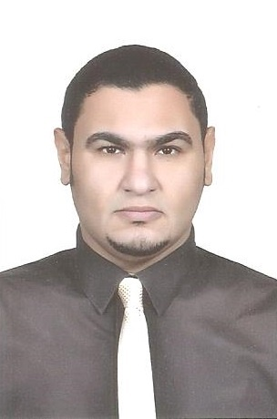

Experience

2022-04:
Present

2018-09:
2022-01

Personal Info

Address

Service and Maintenance Manager at Zamil offshore in Dammam, SA
- Responsible for all (Automotives, Facilities, Equipment and Tools) maintenance and condition and scrape in the shipyard and camps.
- Responsible for working safely and following instruction of safety.
- Lead maintenance teams ( Electrical- Mechanical)
- Plan, direct, lead, and supervise maintenance works.
- Monitoring the activities and managing projects

National Manager at (Arabia Oil Company: Agent of Eagle, Glory Chinese vehicle brands and CNG conversion works).

- Responsible for managing all aspects of the Three Service Centers in three locations (Nasr city, tenth of Ramadan and ELzgazig) for mechanical, electrical and body works.
- Analyze the business to identify opportunities for growth and increased profitability. by outstanding customers satisfaction (CSI), high quality of work (QOW)and the continuous increase in financial income and financial gains for service centers
- Plan, direct, lead, and supervise the work and productivity levels of Associates to ensure Standards are met or exceeded.

El- Zaytoun, Cairo, Egypt
Al- nakhil district , Dammam, KSA.

Phones
002 01011225352 WhatsApp Egypt
00966 547848342 call/WhatsApp KSA

E-mail
Mohammed.l.a.1404@gmail.com

Date of birth
1983-08-01
2017-09:
2018-08
Technical Consultant at (IFG Company)

- I was the head of technical team of the IF group, so I was responsible for all major technical, warranty and training issues for all IFG brands (Zotye - Victory - Shinrai) vehicles.
- The officially link between the Egyptian IFG company and the manufacturer in China for all technical problems, industry defects and all warranty matters.

Responsible for engineers training on technical operations and warranty procedures.

Skills
2015-09:
2017-08
Service Manager at (Ghabbour company GB Auto)

Leadership

Strategic thinking

Software

AutoCAD

Microsoft office
- Manage and coordinate the daily operations of the service Dep.
- Ensure customer satisfaction by delivering high-quality service and resolving any issues or complaints.
- Monitor the progress and quality of repairs and maintenance services to ensure timely completion and compliance with quality standards.
- Manage inventory levels and order parts and supplies to meet service demands.
- Implement and enforce safety regulations and maintenance procedures to ensure a safe working environment.

Languages

Arabic English
2015-02:
2015-08

2008-08:
2015-01

Technical Support Manager at (Bavarian-Brilliance)

- Responsible for all major technical and warranty issues of (Bavarian-Brilliance) vehicles in Egypt.

Workshop Engineer then Workshop manager at Nissan (In & out) of Egypt.

- Leading team of mechanical and electrical technicians to repair.
- Responsible for quality of work.
- Responsible for testing the vehicles after repairing

Education and Training

- Held bachelor’s degree of Engineering (2007) - Automotive Department
    - Held Course of Engine Management (Automotive Electrical Circuits and Components) from Engineering Company for Trading and Training.
- Held (TOEFL) from Ain Shams University.
- Held master’s degree (2017)
(Helwan University - Faculty of Engineering - Automotive Department).
- Prepare (PHD) in Helwan University - Faculty of Engineering
- Held IOSH safety Course.

Interests

Computer science, Poetry, and Chess.

References

All personal references are available upon request.

