CURRICULUM VITAE
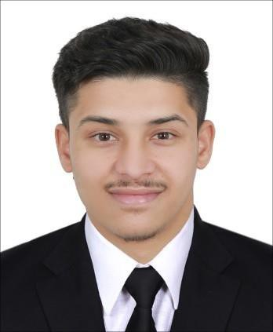
MOHAMMAD AFTAB

Mobile No: 0507358566
Iqama No: 2594193688
Visa Status: Iqama Transferable.
Email ID: mdaftabaalamshekh189@gmail.com

PERSONAL SUMMARY

To work in an environment where I can utilize my skills for accomplishing a responsible job assigned and also to enhance my knowledge for my personal development and career growth and believes best use of the existing abilities and also further my career and the professional development.

CAREER HISTORY

● Worked in Pharma Street Medical Company from period 08-01-2022 to 30-11-2024
as a (Store keeper Warehouse).
Responsibilities: Arranged Ordered, Stored Managed, and Maintained the Managing Inventory level, Organizing and Maintaining stock, Receiving and Dispatching Goods, Keeping Records of Transactions and Ensuring the Smooth Operation OF a Warehouse.
ACADEMIC PROFILE

COURSE INSTITUTE
YEAR
Inter D B College Jayanagar India 2021

SSC B K S HIGH SCHOOL JATULIYA
2018

TECHNICAL PROFILE

Advance MS-Word, Excel, Power Point, Outlook & Internet Knowledge.

SKILLS AND ABILITIES

- Excellent Communication, Inter & Intra Personal Skills.
- Looking to Contribute to the Growth and Development of an Organization.
- Dedication and Drive as a Hard-working Individual.
- Ability to Perform Under Pressure.
PERSONAL DETAILS

● NAME : MOHAMMAD AFTAB

● Father Name : SHEKH TAIYAB

● Date of Birth : 05 APRIL 2003

● Gender : Male.

● Marital Status : MARRIED.

● Permanent Address : WARD NO-09, AT POST CHHATAUNI, POLICE STATION -BASOPATTI
- DISTRICT-MADHUBANI, INDIA.

● Hobbies : Playing Sports, Bike Riding.

● Nationality : Indian.

● Religion : Muslim.

● Languages Known : English, Urdu, Hindi

● Any kind of disability : No

● Willingness to Relocate: Yes

DECLARATION

I hereby declare that all the information furnished above by me in this CV is true. Complete and correct to the best of my knowledge.

