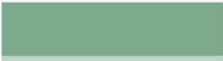

SOMYYAH ABDULHAKIM
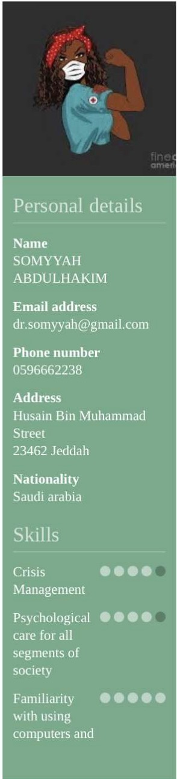
Husain Bin Muhammad Street

Profile

Healt11 is a state of complete physical, mental and social well-being and not merely the absence of disease or infirmity. The enjoyment of the highest attainable standard of health is one of the fundamental rights of every human being without distinction of race, religion,
political belief, economic or social condition.

Education

04/2013 - 01/2015
High school
- \lanjal schools, Makkah

Natura] Sciences

02/2019 - Present
Bachelor's degree in Nursing Specialist Al-Reyadah College of Applied Medical Sciences, Jeddah

03/2019 - 05/2020
Specialist Nursing

Advanced diploma in clinical nutrition
JGTS. Cairo

03/2020 - 06/2021

Employment

10/2023 - 12/2023

09/2019 - 10/2020

MSc Infection Control
IGTS, Cairo

Healthy educated
Erfan hospilal, Jeddah

Casher
Clinical nutrition

Infection Control

Nursing assistant

Courses
Konoz For lhe perfumer. Jeddah

accounting

11/2023 Tranquilizers and their types

11/2023
03/2019

Achievements
CPR
Excellence in public relations

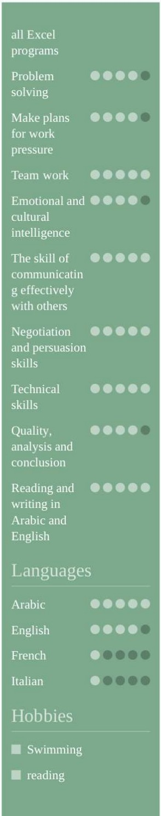
Follow everything new and useful in the world of medicine, nursing, and patient care to provide the highest quality of services and satisfy
all classes of society

  - Follow the trend
  - Social media

Qualities
  - critical thinking

