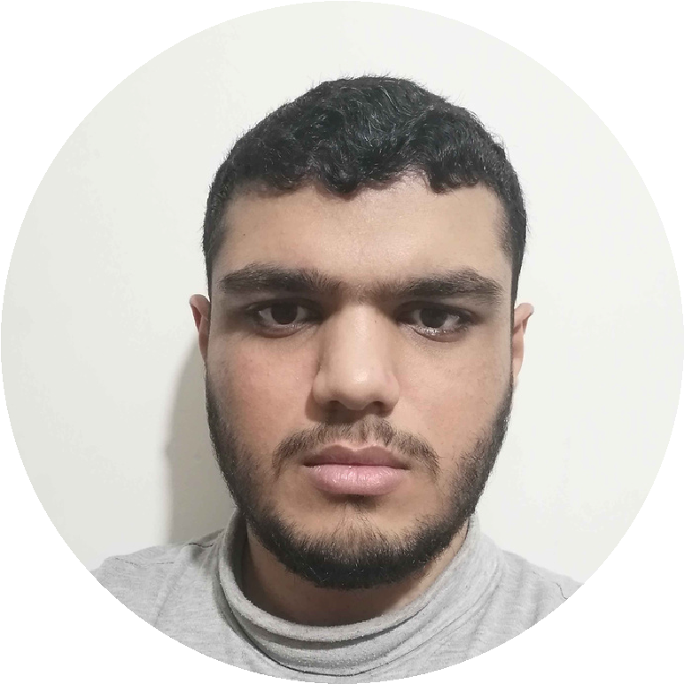
PROFILE
Computer Administration
student.
I consider myself a
responsible and orderly
person.
I am looking foward for my
first work experience.
CONTACT ME
+996 571627782
abdulrehmanwork901@gmail.com
Jabir Ibn Hayyan,
Aziziyah, Jeddah
SKILLS
EDUCATION
AL CORNICHE INTERNATIONAL SCHOOL
Computer Administration career, in
progress.
O/A levels completed.
GRADUATED IN
2023 - 2024.
LANGUAGES
English.
Urdu.
Arabic.
COMPUTER SKILLS
Microsoft Office.
ABDUL REHMAN
ABDUL QAYYUM
High School Graduate
Spreadsheet.
Adobe Premiere pro.
Organized
Communication
Critical thinking
Teamwork
Meeting deadlines
Experienced System Knowledge.

